12th April 2019 - Newsletter 27
Dear Parents/Carers,

We would like to thank you all for your support over the Spring term – it has certainly been a long and busy one but one full of many exciting activities including: KS1 trip to Chester Zoo; KS2 trip to Manchester Runway; EYFS trip to the National Forest Adevernture Farm; year 4 parents’ afternoon; many sporting events; and an extremely positive visit from Ofsted. The staff and children have worked tirelessly over the past 7 weeks and all deserve a well-earned break. We wish you all a very happy Easter and we look forward to seeing you fresh-faced for the Summer term on Monday 29th April.

KS2 trip – Runway Visitor Park, Manchester.
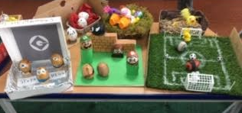
On Wednesday, Mr. Bridge’s class, Mr. Suddaby’s class and Miss Lovatt’s class went to visit the Runway Visitor Park (Manchester Ariport). During the day, we learnt about the Wright Brothers and their Wright Flyer, as well as more recent aircraft, such as the Supersonic Concorde and the awesome A380 – the largest passenger airliner in the world. We even got to sit in the cockpit of a Monarch DC10 aeroplane.

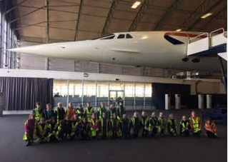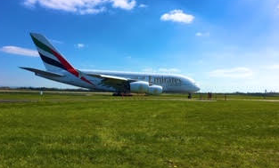

G2BG Scooter Day

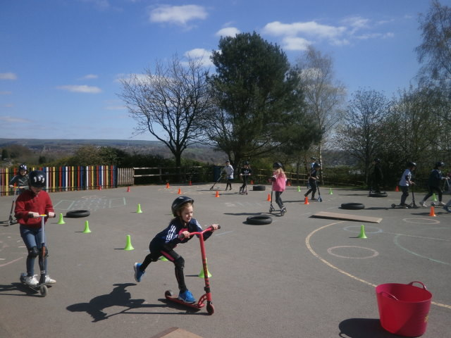
On Thursday, the children had a fantastic day taking part in scooter activities on the school playground - organised by ASM Sports. This was a treat to celebrate and reward children for their excellent behaviour this term. The children were praised by the ASM staff for their impeccable manners and scooter skills! Well done everyone!

Easter Bonnet parade
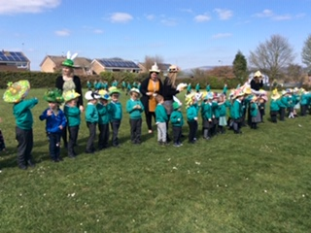
Our Nursery and Reception children thoroughly enjoyed our Easter Bonnet Parade on Wednesday. Thank you to all who helped to make their fabulous bonnets at home and for the great turn-out for the afternoon.

Easter Egg Decorating Competition
A huge well-done to all children for your Easter egg decoration entries and thank you to all who helped to make the designs at home. We have been really impressed with the time and effort that has gone into producing such fantastic creations. It was a really tough decision to pick a winner but congratualtions to Mia B, Ethan M & Harvey in KS1 and Lilly P, Ben G & Jack D in KS2 who are this year’s winners.
Polite Reminders

PE Kit
We are still noticing that more and more children are turning up to school without PE kits or with the incorrect kit - unfortunately, football shirts, rugby shirts and cricket shirts are not an item of PE kit. Children must ensure that they have their full PE kit in school throughout the week - white t-shirt, black shorts, PE pumps and trainers (for outdoor sessions). Although PE is timetabled for specific days, there will be occasions when a slot is switched, or an additional opportunity for PE presents itself – for example, if the weather is warm. Thank you.

Attendance – 1st – 5th April 2019

School Attendance Target: 97%
The school has set an attendance target of 97%, therefore every child’s target is 97% attendance over the course of the academic year. We are delighted to inform you that we have achieved our target this half term with 97.1%. Well done, everyone - let’s see if we can better this attendance next term!

Class | Lates | % Attendance
Mrs Sharman/Miss Brackstone
Mrs Hammersley |  | 97.6
Miss McDonald |  | 98.6
Mrs Scott |  | 98.6
Miss Lovatt |  | 95
Mr Suddaby |  | 96.9
Mr Bridge |  | 98.3

Congratulations to Miss McDonald’s & Mrs Scott’s class for achieving the highest attendance.

Lunch Menu – week commencing 29th April 2019

 | Mon | Tues | Wed | Thurs | Fri
Option 1 | Pizza | Chicken Potato  Bake | Roast of the day | BBQ Beef Meatballs & Rice | Fish & Chips
Option 2 | Chinese Veggie Noodles | Veg Pasta Bolog-nese | Jacket Pots | BBQ Tortilla bake | Veg Hotdog

